**AMRITSAR GROUP OF COLLEGES**

**Autonomous status conferred by UGC under UGC act-1956, (2f), NAAC-A Grade**  
(Formerly Known as Amritsar College of Engineering & Technology | Amritsar Pharmacy College)

**Synopsis**

**On**

**“EXAMINATION MANAGEMENT SYSTEM”**

Submitted in the Partial fulfilment of the requirement for the Award of Degree of

**Bachelor of Technology**

in

**COMPUTER SCIENCE & ENGINEERING**

(2020-2024)



|  |  |
| --- | --- |
| **Submitted to:**  Er. Ajay Sharma  (Associate Professor) | **Submitted by:**  Kartik Arora (2132015)  Rohan Sharma (2000184)  Rohin Biyal (2000185)  Rudra Pratap Samal (2000189) |
|  |  |

**DEPARTMENT OF COMPUTER SCIENCE AND ENGINEERING**

**Amritsar Group of Colleges, Amritsar**

**Table of Contents**

|  |  |
| --- | --- |
| Introduction of Project | **1** |
| Tools Used | **3** |
| Group Members Role | **5** |
| System Analysis and Data Tables | **6** |
| Screenshots | **8** |
|  |  |

**INTRODUCTION OF THE PROJECT**

This project aims at building an **Examination Management System**. It is divided into different modules to make it more user-friendly. The front –end is designed using Python3 – PyQt5 Tool.

This project has been developed to override the problems of prevailing in the practicing manual system. This software is supported to eliminate and reduce the hardships faced by the existing system. Moreover this is designed for the particular need of the institute to carry out operations in a smooth and effective manner.

The purpose of the Examination Management System is to automate the existing manual system by the help of the computerized equipment and full-fledged computer software, fulfilling their requirements so that the valuable data/information can be stored for a long period with easy accessing and manipulation of the same.

The main objective of the Project on Examination Management System is to manage the details of Exams, Students, Courses, Semesters and the Subjects. It can manage all the information about students’ academic details along with their required information.

The project is built with administrative authorization where multiple users with different roles can access and manipulate the data/information according to their roles.

**Functionalities provided by Examination Management System:**

* Manages the users such as DEOs, Evaluators and Admins, only by authorized access.
* Manages the data/information of the students (Roll no., Name, Course, Semester and their results)
* Adding, Updating and Deletions are possible in different modules according to the necessities.
* To increase the efficiency of managing the exams and results in an institution.

**Features of Examination Management System:**

* Authorized LogIn can create, update or delete the users presently working with the system.
* Authorized LogIn also has full access of all the modules which again gives it full authorization to add, update or delete in students, subjects, exams and result related details.
* This system is built for only for the users who will manage the pre-examination data and post-examination data.
* Pre-examination refers to selection of subjects and generation of date-sheets of the examination for each course and semester currently present.
* Post-examination refers to generation of marks and results of each student, maybe based upon MCQs which can use OMR to generate result, or descriptive examination which needs to upload result manually by DEO.
* For pre-examination, if any changes in subjects or date-sheets need data to be updated which is already stored, then only Admins with any designation of the institution will have right to do so.
* For post-examination, if anyhow result which is stored or marks which are generated are not valid or need to be changed, authorized LogIn like DEOs with any designation of the Institute can update the data.
* All users are provided a feature to update their profile to some extent.
* Whereas Admin with any designation, of the Institute can update the details of the other users which are not accessible by those.
* Each module provides a well design to show, create, update and delete the contents related to the relations required in this system, whereas some modules don’t have few feature like creating and deleting content such as creating subjects or deleting students’ details.
* Date-sheet Generator is an excellent feature of this system where any user with Admin role can generate date-sheets of each semester with one click.
* Marks/Result Viewer is another feature of this system where user will be provided with graphical views of any student, class, branch, course or semester results and may have feature to project out that views.
* The Marks/Result Views may use Bars representation, Pie representation or even basic Table representation according to the user needs.
* The Marks/Result generator may use both OMR Scanner and Manual Data Entry, or only one of these, for generating each student’s result.
* The Main Window may supposed to have one Mask Layer Button which will mask the whole window for the user, if it is needed and then it can only be unmasked if provided right credentials (password) for that User.

**TOOLS USED**

|  |  |
| --- | --- |
| **Front-end:** | **Python PyQt5** |
| **Back-end:** | **Oracle Database** |
|  |  |

* 1. **Introduction to PyQt5**

PyQt is a Python library for creating GUI applications using the Qt toolkit. Created by Riverbank Computing, PyQt is free software (GPL licensed) and has been in development since 1999. PyQt5 was released in 2016 and last updated in October 2021. PyQt5 is the Qt5-based edition of the Python GUI library PyQt from Riverbank Computing. PyQt which consists of more than six hundred classes covering a range of features such as

* Graphical User Interfaces
* SQL Databases
* Web toolkits
* XML processing
* Networking

These features can be combined to create advanced UIs as well as standalone applications. A lot of major companies across all industries use Qt. Some examples are LG, Mercedes, AMD, Panasonic, Harman, etc.



* 1. **Introduction to Oracle Database**

Oracle database (Oracle DB) is a relational database management system (RDBMS) from the Oracle Corporation. Originally developed in 1977 by Lawrence Ellison and other developers, Oracle DB is one of the most trusted and widely-used relational database engines.

The system is built around a relational database framework in which data objects may be directly accessed by users (or an application front end) through structured query language (SQL). Oracle is fully scalable relational database architecture and is often used by global enterprises, which manage and process data across wide and local area networks. The Oracle database has its own network component to allow communications across networks.

A key feature of Oracle is that its architecture is split between the logical and the physical. This structure means that for large-scale distributed computing, also known as grid computing, the data location is irrelevant and transparent to the user, allowing for a more modular physical structure that can be added to and altered without affecting the activity of the database, its data or users. The sharing of resources in this way allows for very flexible data networks whose capacity can be adjusted up or down to suit demand, without degradation of service. It also allows for a robust system to be devised as there is no single point at which a failure can bring down the database, as the networked schema of the storage resources means that any failure would be local only.



**GROUP MEMBERS ROLE**

|  |  |
| --- | --- |
| **Student Name** | **Tasks Assigned** |
| 2132015 - Kartik Arora | UI Testing   * Verification and testing of user interface * Management of team work and schedule * Enhancement of user experience by the product under development |
| 2000184 – Rohan Sharma | Database Designing and Validating   * Designing of database required under development of the project * Designing and determination of tables required for different modules * Setting the relationships between different tables * Validate relations after development of each module |
| 2000185 – Rohin Biyal | UI Designing and Validating   * Designing of UI in user-friendly manner * Developing and maintaining the User Interface * Developing new user-facing features * Validate interface for development of different modules |
| 2000189 – Rudra Pratap Samal | UI and Database Connecting   * Constructing the bridge between UI and Database Relations * Striking a balance between functional and aesthetic design * Maintaining the workflow of operations performed between front-end and back-end |

**SYSTEM ANALYSIS AND DATA TABLES**

* **USER**

|  |  |  |
| --- | --- | --- |
| **COLUMN NAME** | **TYPE** | **CONSTRAINTS** |
| USERNAME | VARCHAR2(10) | PRIMARY KEY |
| PASSWORD | VARCHAR2(12) | NOT NULL |
| NAME | VARCHAR2(20) | NOT NULL |
| DESIGNATION | VARCHAR2(15) | NOT NULL |
| ROLE | VARCHAR2(15) | NOT NULL |
| CONTACT | NUMBER | UNIQUE |

* **STUDENT**

|  |  |  |
| --- | --- | --- |
| **COLUMN NAME** | **TYPE** | **CONSTRAINTS** |
| ROLL NO | NUMBER(6) | PRIMARY KEY |
| SNAME | VARCHAR2(30) | NOT NULL |
| COURSE | VARCHAR2(15) | NOT NULL |
| SEM | NUMBER | CHECK (SEM BETWEEN 1 AND 8) |
| BATCH | NUMBER(6) | CHECK (BATCH>2000) |

* **SUBJECT**

Each semester of each course will have one table for the subjects

|  |  |  |
| --- | --- | --- |
| **COLUMN NAME** | **TYPE** | **CONSTRAINTS** |
| SUB | VARCHAR2(20) | NOT NULL |
| SUBCODE | VARCHAR2(10) | PRIMARY KEY |

* **DATESHEET**

|  |  |  |
| --- | --- | --- |
| **COLUMN NAME** | **TYPE** | **CONSTRAINTS** |
| DATE | DATE | NOT NULL |
| SUB | VARCHAR2(20) | NOT NULL |
| SUBCODE | VARCHAR2(10) | REFERENCES SUBJECT(SUBCODE) |

* **MARKS/RESULT**

Each semester of each course will have one table for the result of the students

|  |  |  |
| --- | --- | --- |
| **COLUMN NAME** | **TYPE** | **CONSTRAINTS** |
| ROLLNO | NUMBER(6) | REFERENCES STUDENT(ROLLNO) |
| SUBCODE1 | NUMBER | CHECK (SUBCODE1<=100) |
| SUBCODE2 | NUMBER | CHECK (SUBCODE2<=100) |
| SUBCODE3 | NUMBER | CHECK (SUBCODE3<=100) |
| SUBCODE4 | NUMBER | CHECK (SUBCODE4<=100) |
| SUBCODE5 | NUMBER | CHECK (SUBCODE5<=100) |
| TOTAL | NUMBER | CHECK (TOTAL<=100) |

**SCREENSHOTS**

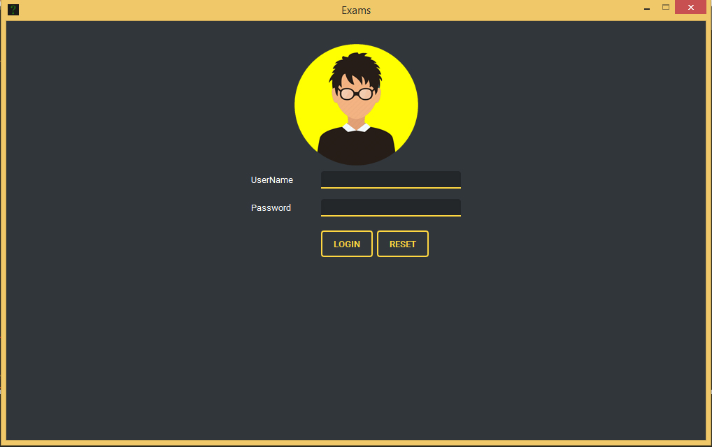

**Fig. 1:** LogIn Screen.

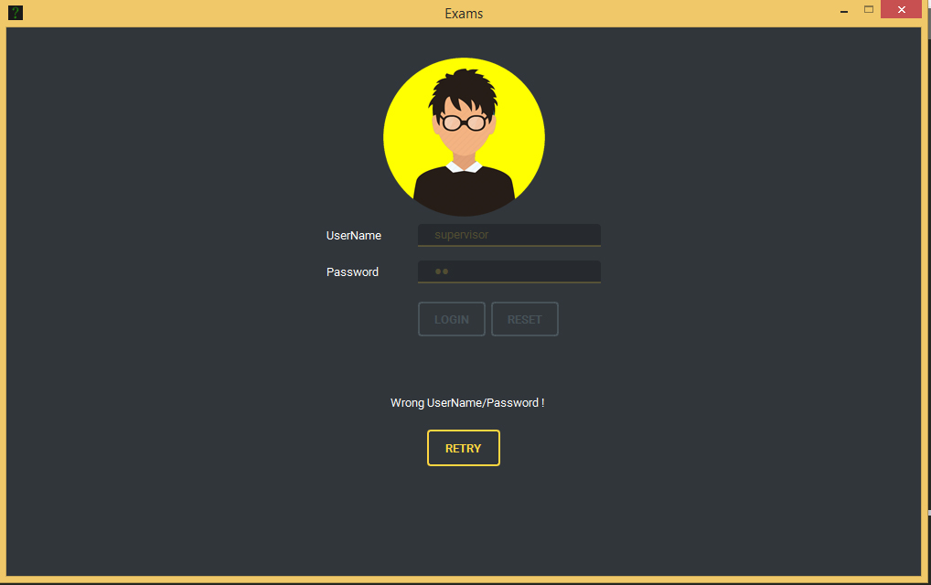

**Fig. 2:** Wrong password filled while logging in

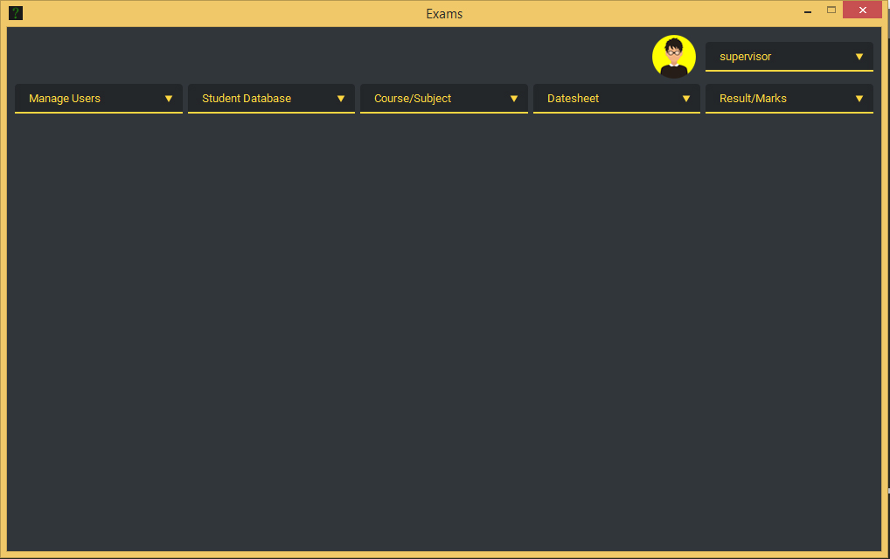

**Fig. 3:** Main UI Window after successful LogIn

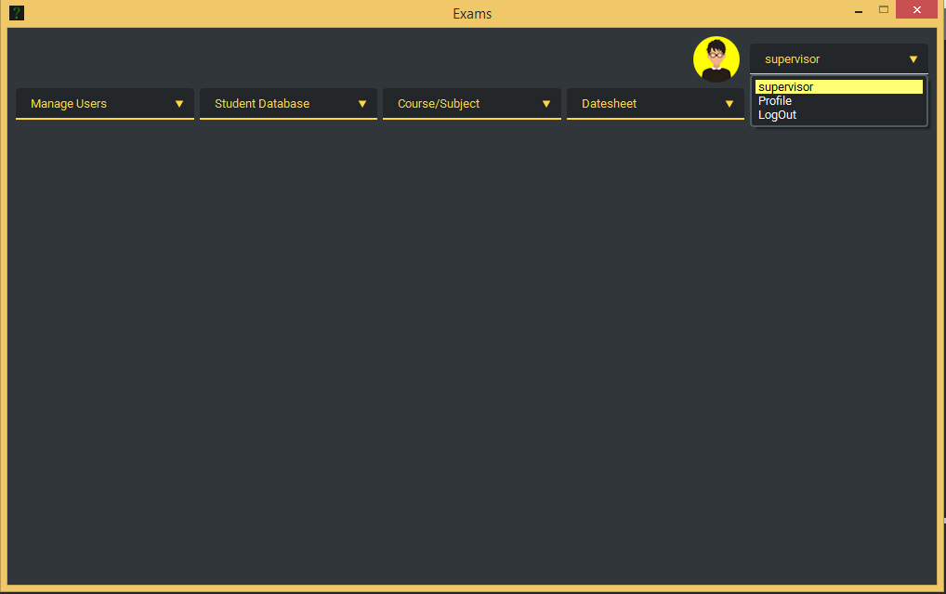

**Fig. 4:** Profile Menu

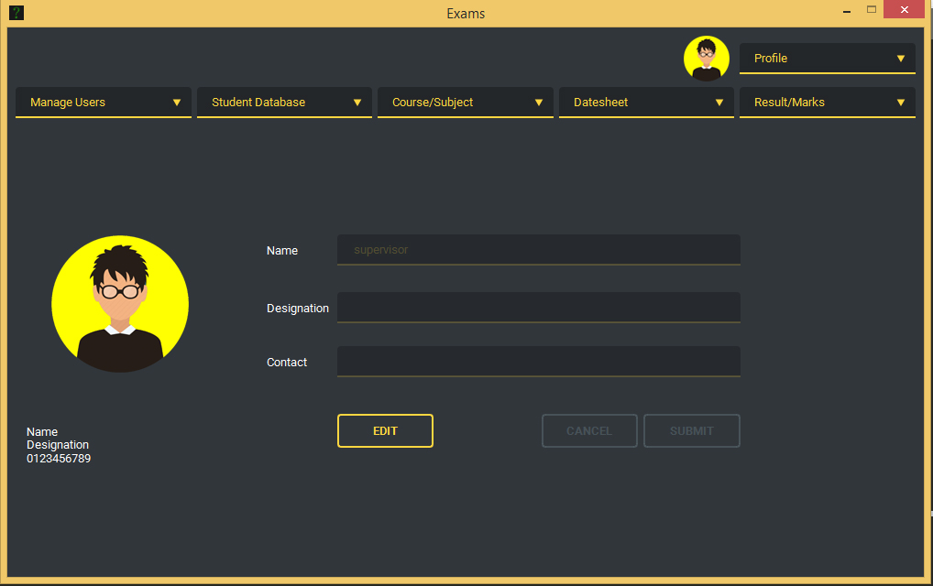

**Fig. 5:** Change/Update Profile

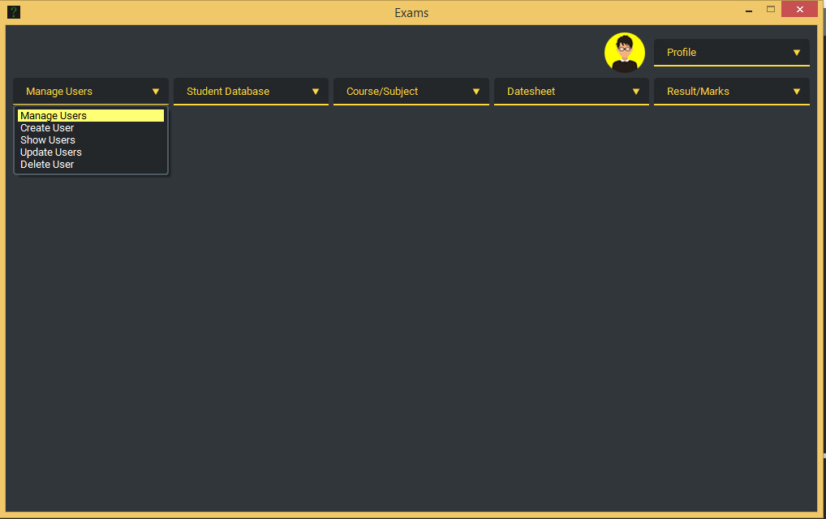

**Fig. 6:** User Menu

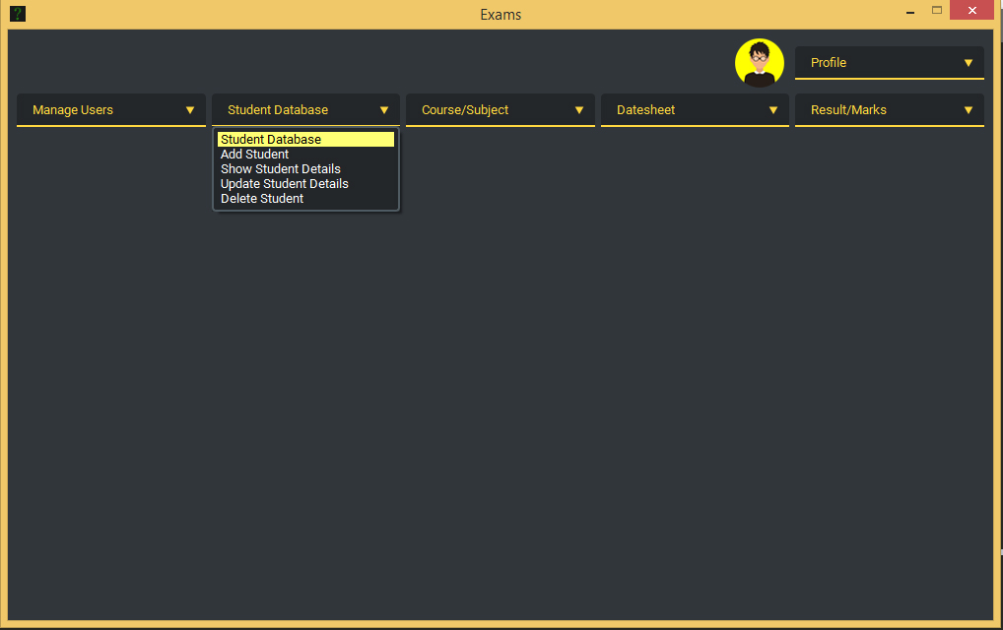

**Fig. 7:** Student Database Menu

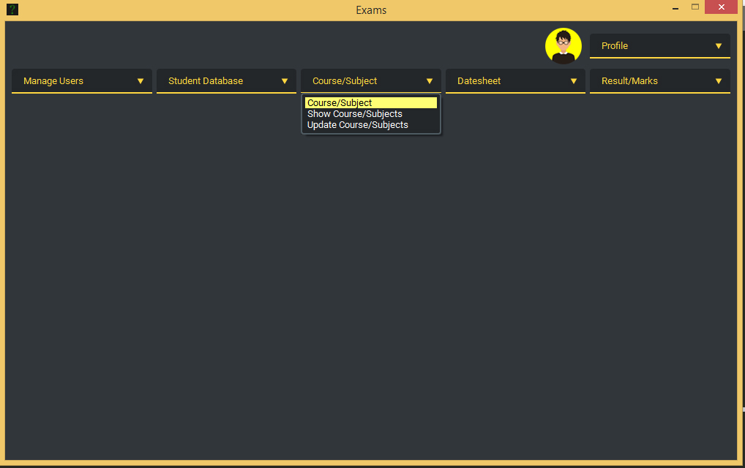

**Fig. 8:** Course/Subject Menu

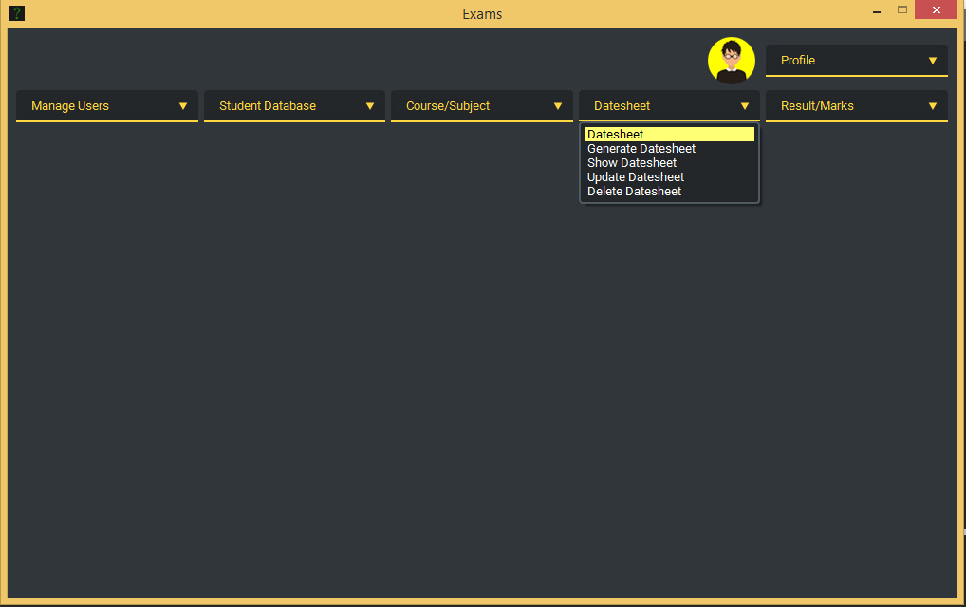

**Fig. 9:** Date-sheet Menu (Pre-Examination)

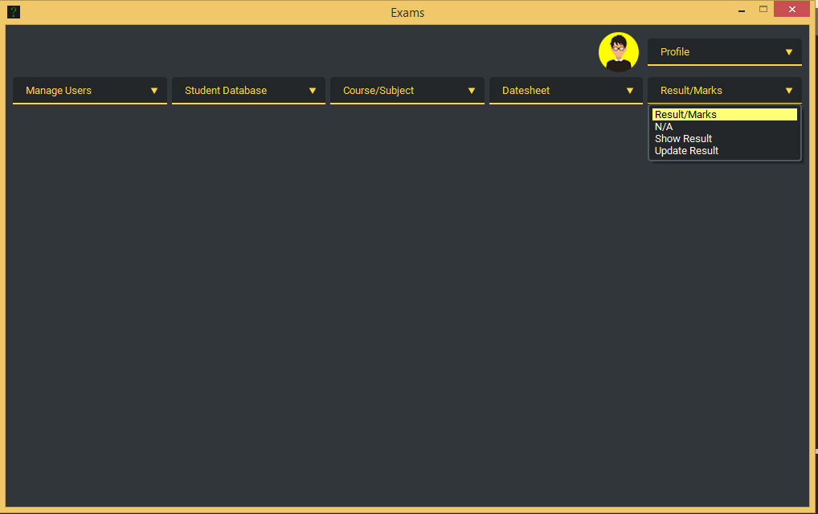

**Fig. 10:** Results/Marks Menu

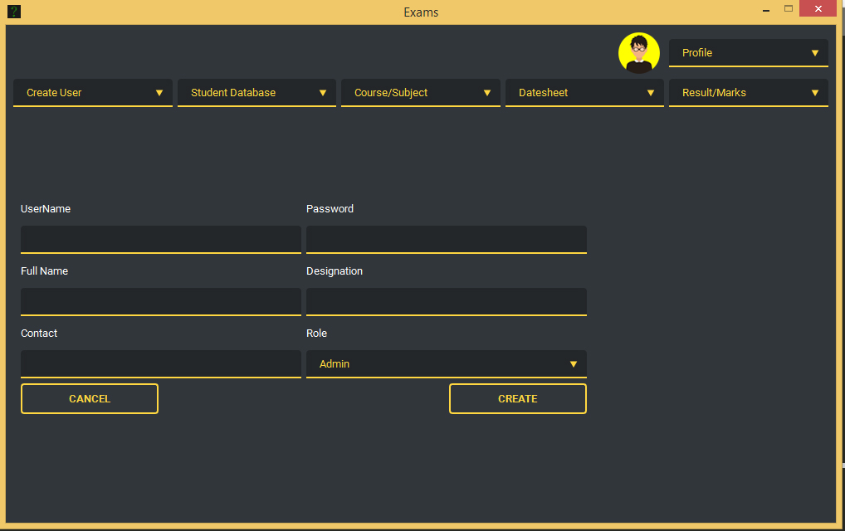

**Fig. 11:** Create User Window

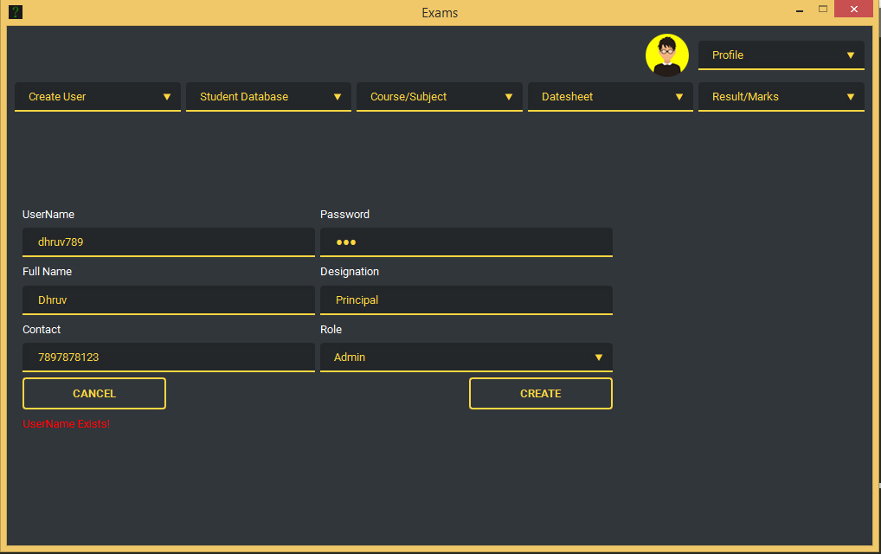

**Fig. 12:** Raising error if New User is being created with already existing UserName

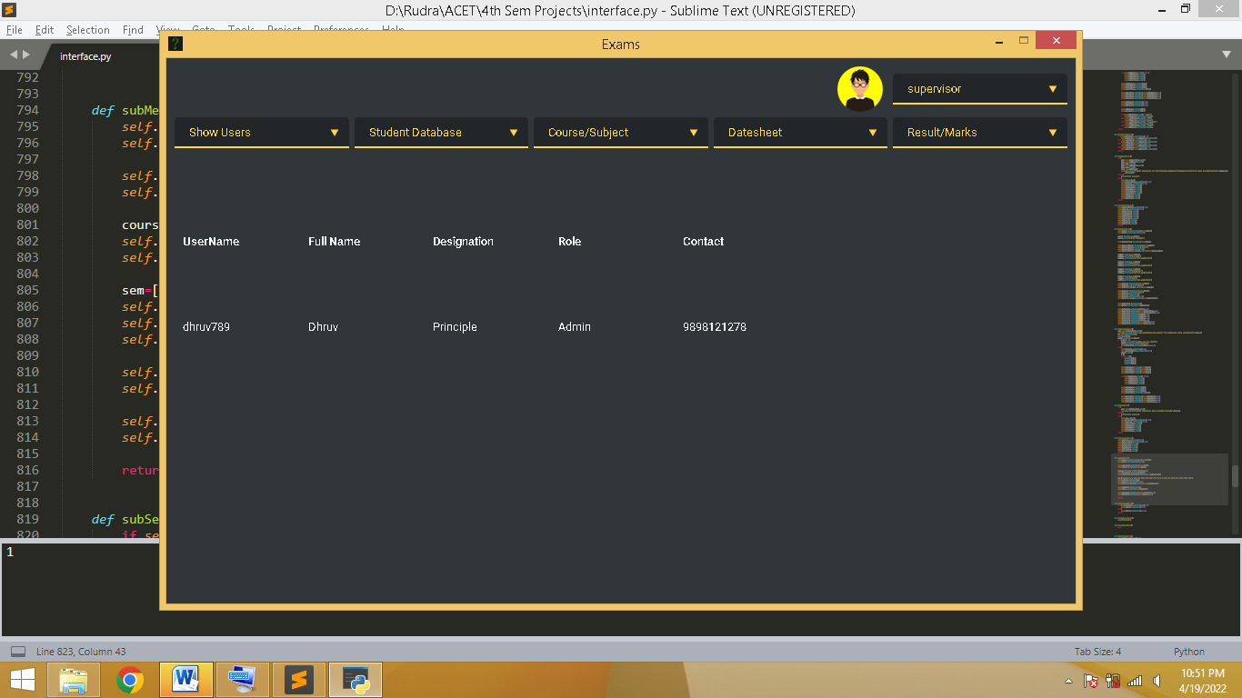

**Fig. 13:** Displaying currently present users

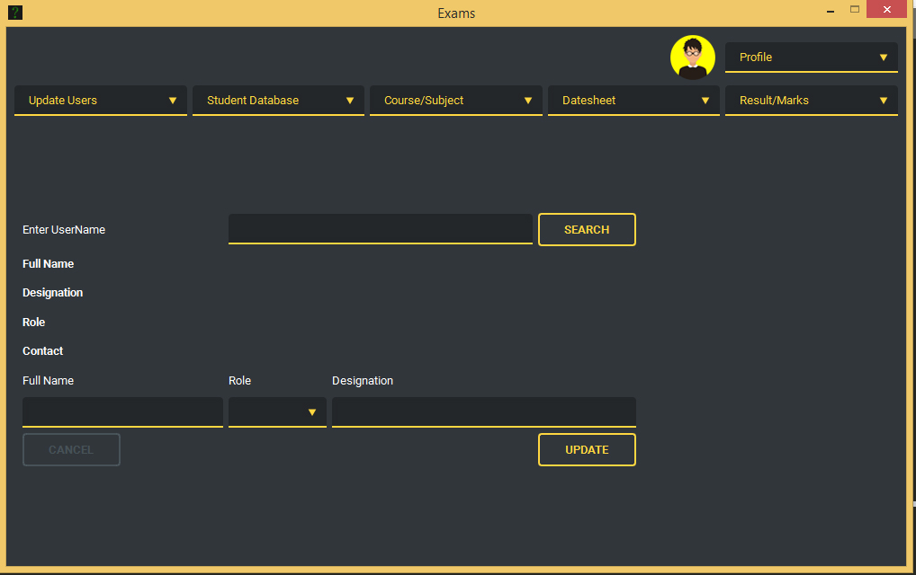

**Fig. 14:** Update User Window

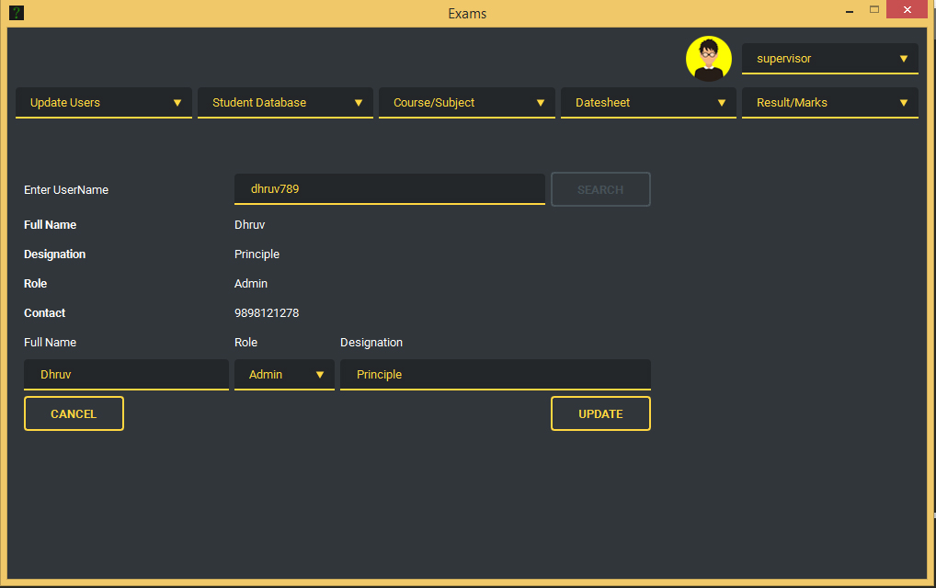

**Fig. 15:** Retrieving User details from database

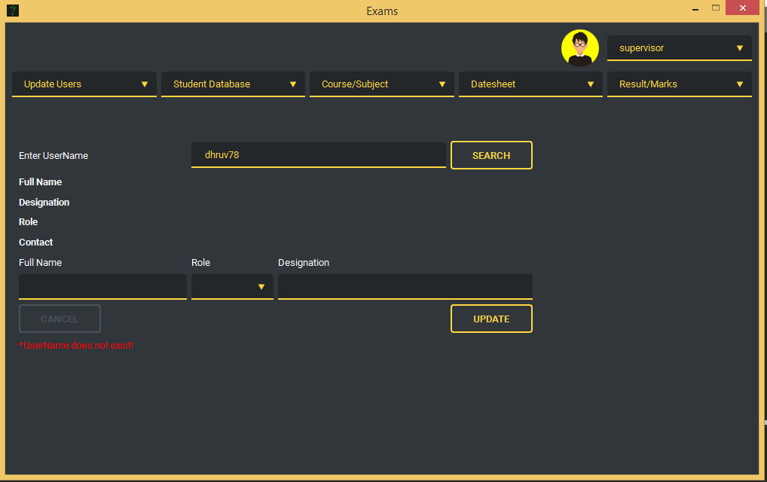

**Fig. 16:** Raising error message if UserName filled is not present/never created

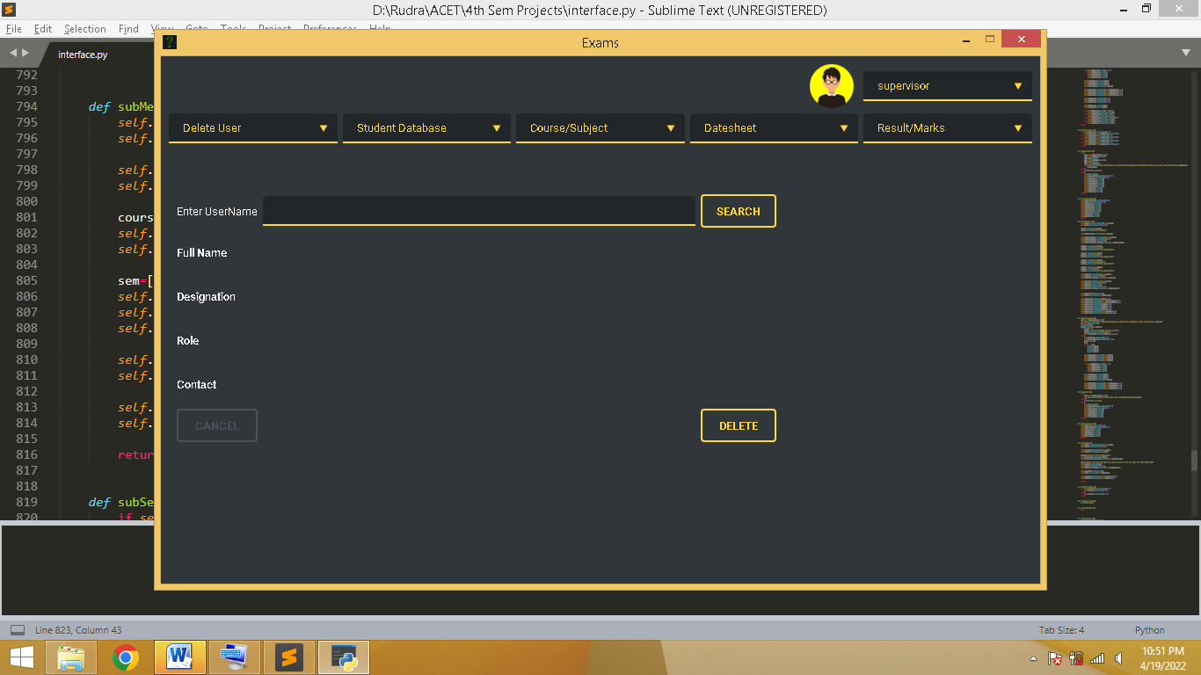

**Fig. 17:** Delete User Window

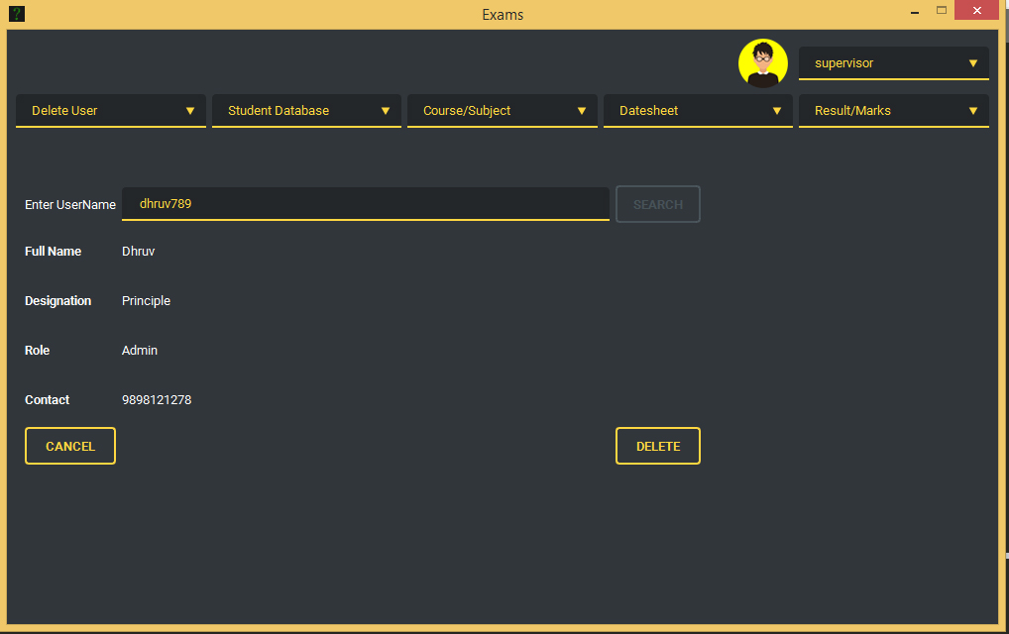

**Fig. 18:** Retrieving User details which is to be deleted

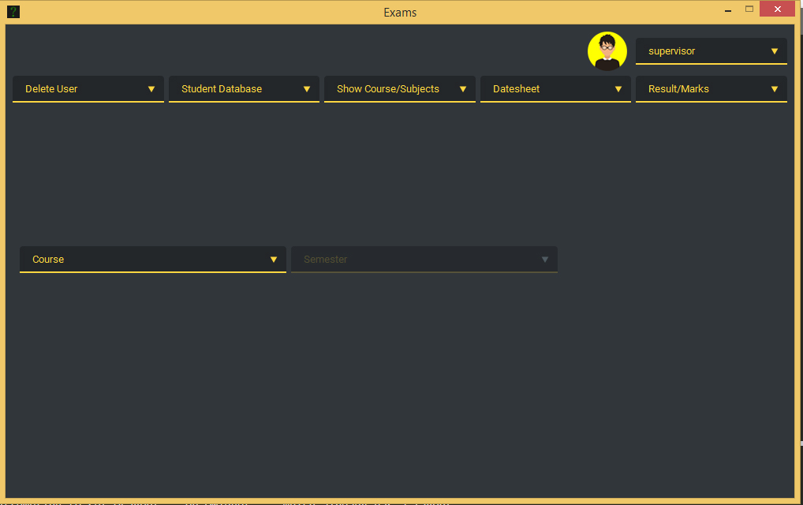

**Fig. 19:** Course/Subject Window

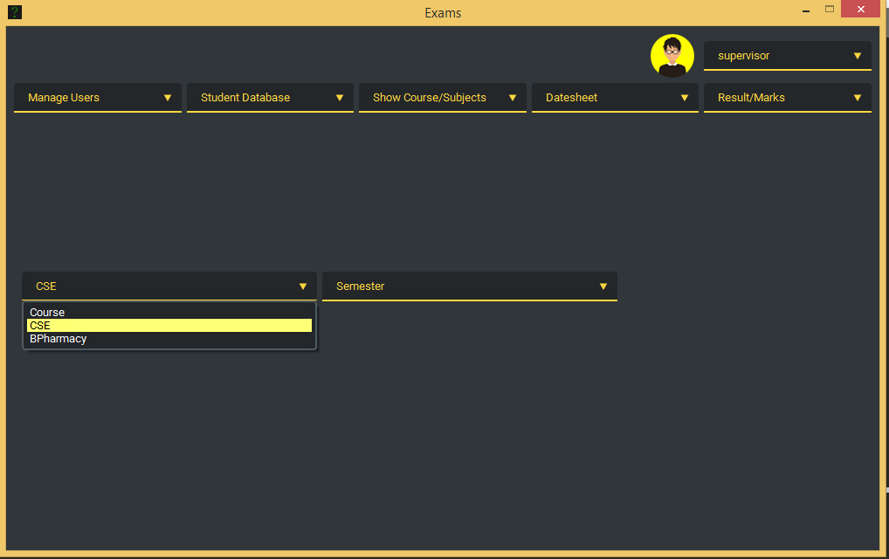

**Fig. 20:** Selection of course enables selection of corresponding semester

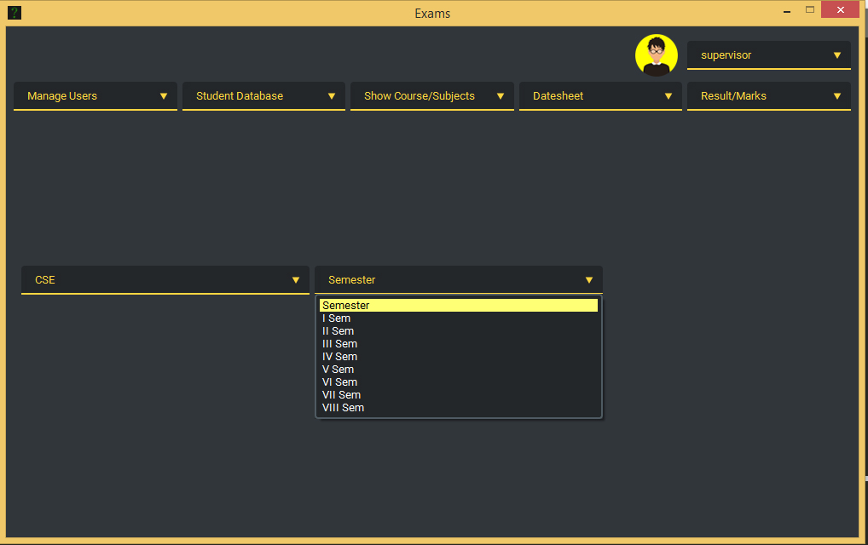

**Fig. 21:** Selection of Semester from semester list